March 2019
Our Lady of Grace
Council #13243
Knights of Columbus
Palm Bay, Florida USA

“ We are called to preach the Gospel in word and in deed, building up the civilization of love.” ………….Carl Anderson, Supreme Knight

Grand Knights Message: We started February with a Membership Drive that brought was us one candidate for membership. Anthony Alabruda was interviewed by the Admission Committee on Feb. 19 and found acceptable. We are working with Anthony to setting a date for his Admission Degree.

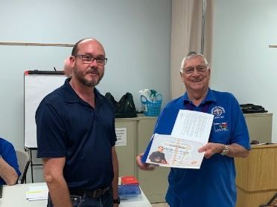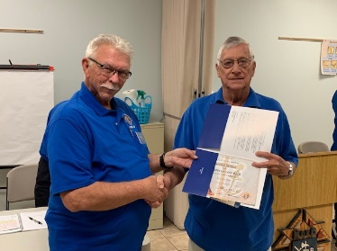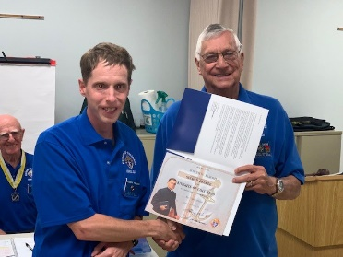
Charlie, Dan and Joseph received their Second Degree Certificates at the Feb. business meeting.
Thanks to our Financial Secretary and 3 Trustees we were able to submit our semi-annual audit to Supreme on time. Our February social meeting was a presentation by a representative (Jane) from Habitat for Humanity. She spoke on all the different types of programs they are involved in and how to volunteer for future builds.
On Wed. Feb. 20, 4 council members went to F.I.T. to cook and serve spaghetti dinners for the hungry college students. Always a very appreciative group. Of course Fr. Mike and Fr. Doug joined us for dinner.
Thursday Feb. 28, myself and Phil Rucki from SVDP attended a seminar at the bishop’s request titled Harmonizing Ministries at Divine Mercy Church on Merritt Island.
We scheduled a Mardi Gras Masquerade party but had to cancel it as there were too many other big events being held that same weekend, e.g. Grant Seafood Festival, Melbourne Strawberry Festival. We will try to plan another event later in the Spring.
Membership – We are in the Lenten season, a time the church asks us all to renew our faith and commitment to God. The Knights of Columbus offers the perfect solution, through service, charity, and faith programs. Go out and help a Catholic man to renew , but don’t stop there. Invite a suspended or withdrawn Knight back home. Ask an inactive man to give just one hour in service to God this year. Ask an active member to consider serving more by taking a leadership role. Have your recruiter’s table at every event, and every Knights sponsored Lenten activity to ask someone to join.
What’s happening in March:
Mar. 5 – 6:00 PM – 1st degree prior to business meeting Mar. 5 – Council Business Meeting – Nominations for council officers Mar. 9 & 10 – Church Membership Drive after all masses. Mar. 16 – 4 PM – Kickball game vs Residents of Promise of Brevard at Field of Dreams.( presentation of Tootsie Roll checks to both organizations.) Mar. 23 8 AM – SVDP walk for the poor. Mar. 23 -9:30 AM – Lenten Rosary (front of church) Mar. 25 – Knights of Columbus Day of the Unborn Child - Council members and wives and CCW will tour Pregnancy Resource Center Mar. 26 – Tuesday 9 AM Mass for Life Mar. 29 – K of C Founders Day ( event to be determined)
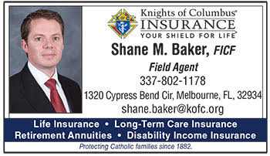
Insurance Agent’s Report
We Stand Strong On Ethical Ground
Some people believe that ethics in business is a contradiction in terms. They think that in order to be profitable, a company and its leaders must abandon morality and embrace the dark, greedy side that they see so often in the news and in movies.
At the Knights of Columbus, we know this isn’t true. A business can be both ethical and successful. We are.
As a Catholic organization, we understand the value and importance of our core beliefs and the original mission of Venerable Father Michael J. McGivney. In fact, much of the strength and financial security we provide to members and their families can be attributed to our ethical, moral standards.
More than 96 percent of Knights who buy our life insurance keep it, year in and year out. The Order takes this commitment to our members very seriously. This means carefully planning when it comes time to invest. Our professional staff researches all transactions to insure that they fall in line with Catholic values. If a transaction makes them uncomfortable, they don’t make it.
“We exclude any company engaged in activity that conflicts with Catholic moral teaching: companies directly involved in abortion, contraception, human cloning, embryonic stem cell research, for-profit health care that pays for any of these, or pornography,” said Supreme Knight Carl Anderson. “There are many companies in the pharmaceutical and communications industries that would undoubtedly provide excellent returns for us, but which are not in our portfolio because they engage in research and development or programming in ways that violate the sanctity or dignity of human life.”
In the end, the Knights of Columbus investment strategy is motivated by morality, not money. Yet, each year we remain profitable, increase our assets and stay dedicated to this vision that will keep the Order financially sound for generations to come.
But don’t just take our word for it. In 2016 the Knights of Columbus was named a “World’s Most Ethical Company” by the Ethisphere Institute for the third year in a row. We were one of only two life insurance companies to earn the honor.
“Faithful Catholics have choices when buying life insurance,” said the Supreme Knight. “But they know that at the Knights of Columbus their policy is supplied by an insurer that shares their moral and ethical values and is guided in all of its investment and sales practices by those values.”
Contact me today to learn more about our products.

Sane.Baker@kofc.org Phone: 1-331-802-1178

Archbishop Lori’s Challenge for February 2019
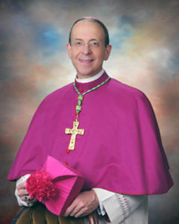
After all the people had been baptized and Jesus also had been baptized and was praying, heaven was opened and the Holy Spirit descended upon him in bodily form like a dove. And a voice came from heaven, “You are my beloved Son; with you I am well pleased.” — Gospel for Jan. 13, Lk. 3:21-22
Think about it. Do you really see yourself as a beloved son in whom your Heavenly Father is well pleased? To be honest, most men, including this archbishop, go through seasons when we don’t seem to sense that our father is well-pleased. Maybe we see ourselves as self-made men who don’t owe our father anything. Maybe we did not experience love from our dad, and the very idea of being beloved is ludicrous. Maybe instead of Jesus’ actual words, we hear, “This is my wayward son, in whom I am much disappointed.” Yet we know that we are baptized into Christ and share in his identity as the beloved son. Being beloved sons is the bedrock of our identity. The plain fact is that your heavenly Father is well-pleased with you.
The Challenge This month: I challenge you to hear the Heavenly Father saying these words — “you are my beloved son” — personally to you, and reflect on your identity in him. I recommend that you do so, if possible, in Adoration. Secondly, I challenge you to spend time with someone who loves you unconditionally. Ask them why? Their answer should give you a small glimpse of God’s unconditional love
. Anniversary of Knighthood
03/08 – Juan Linares 03/17 – Osvalso Agrait-Ruiz 03/01/68 –Pedro Fernandez 03/28/06 –Christopher Tomkins 03/09 – Allen Luceno 03/18 – Ed Trotter 03/01/84 –Robert Grosch 03/08/07 – Denis Richard 03/10 –Randy Allen 03/23 – Greg Pierre 03/01/88 –Sigfredo Santiago 03/22/10 –Tim Jacques 03/12 – Ryan Smith 03/24- Norman Carrasquillo 03/24/97 –Andy Miles 03/22/10 –Mike Otten 03/13 – Juan Marrero 03/29 –Hector Nieves 03/06/06 –Francis Phillip 03/28/17 –John Hooi 03/15 – Amaefule Chukwunenye 03/25 – Hector Cumba 03/28/06 –David Gonzalez
The Family Fully Alive BUILDING THE DOMESTIC CHURCH
March: Family Difficulties
All families face difficulties. At such critical moments, it is important to learn how to suffer well and to suffer together with Christ. Suffering, if given to the Lord, can bring families closer together and strengthen their love. Breaking Open the Theme Catholic families today face many challenges in the very real and normal frustrations of marriage and family life. The world tells families that they can simply walk away from such situations and choose whatever lifestyle or solution makes them feel happy as individuals. However, this escapism is not the Christian way. As St. John Paul II often reminded people, the Christian way of suffering begins with hope and the firm conviction that “God’s strength is always far more powerful than your difficulties.” Relying on God’s strength, families should not be fearful to recognize their struggles together and bring them before the lord in prayer. Although they may not experience instant relief or be given a solution to fix the problem they are facing, the lord will help them carry their crosses to the very end, providing comfort and healing along the way. After taking these first steps, families need to remember that they must constantly undergo conversion and healing. They cannot stop talking about their daily concerns or problems; by doing so they run the risk of weakening their relationships. Open conversation unites family members and may lead them to discover the source of their pain and struggles. In particular, it may bring up issues that the family is struggling to express or even unbury deep concerns. It may be painful to face problems, especially those that have no easy solution, but families must do so with honesty and love. If families start with these first few steps, their wounds can be transformed into points of intimacy with God. Suffering need not be only negative; through faith it can be transformed into great love. It is this miracle of transforming suffering into joy that is at the heart of Christian salvation.
There is no family that does not know how selfishness, discord, tension and conflict violently attack and at times mortally wound its own communion: hence there arise the many and varied forms of division in family life. Every family is called by God to have the joyous and renewing experience of “reconciliation,” that is, communion reestablished, unity restored.
- What are our family’s struggles? How might we work together as a family to heal these areas of hurt or confusions, without fleeing from challenges, shutting anyone out or giving in to despair?
- How can we as family better rely on God’s strength in times of difficulty? In what ways can we allow Christ’s love to make our suffering fruitful and deepen our love?

.

