February 2019
Our Lady of Grace
Council #13243
Knights of Columbus
Palm Bay, Florida USA

“ So could you men not keep watch with me for an hour?” (Matthew 26:40)
The Eucharist is the source and foundation of the principles of our Order: Charity, Unity, and Fraternity. As Knights we have a duty to promote devotion to Jesus in the Most Blessed Sacrament.
Time spent together is essential to building our bonds of fraternity. We are encouraged to make time for adoration.

Grand Knights Message:
January was another busy month for the council. We started out by welcoming two new members at a 1st degree exemplification prior to our business meeting.
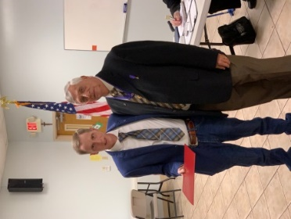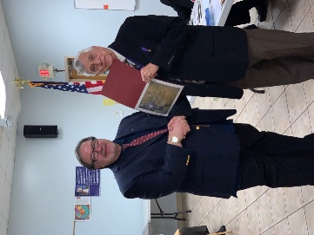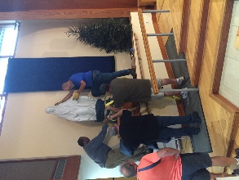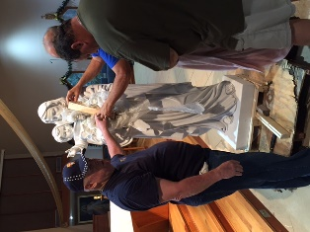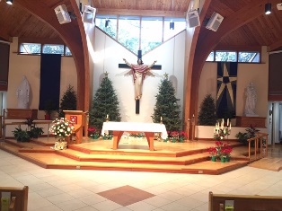
Joseph Yarosh Gary Patrovich
The marble statues purchased by our brother SK Ed Schmitt arrived and several Knights assisted in placing them at the back wall of the Altar. Very beautiful addition to the church. A huge “ Thank You” to Ed for his generous donation to the church and parish.
From Jan.14 thru 22, 7 members of the council participated in a Novena for Life. 2 other non- members participated as well. This was a required proram under the Faith in Action program.
On Saturday, Jan. 19 our council joined the other 4 councils in our district in a District Dinner/Dance fundraiser for an ultrasound machine and support for a local pregnancy resource center.
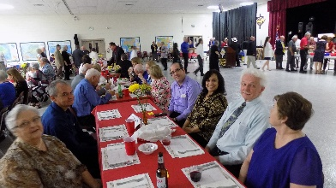 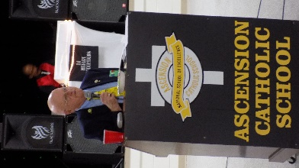 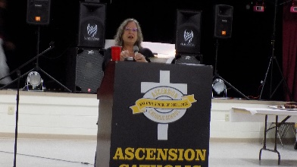 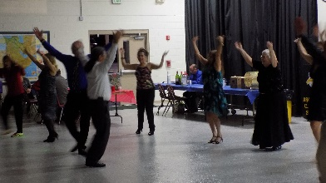 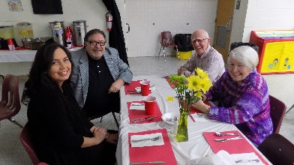 Guest speakers were Paul Gloekler, FL. State Council Director of Pro-Life Events, and Linda Evans, Director of Pregnancy Resource Center in Melbourne. The food was great, WOW so many desserts to choose from, dancing to a DJ. Only 5 Knights and 4 wives represented OLOG Council. We sold $500 worth of tickets of our $1000 commitment so we had to donate another $200.00.
The council officers met and have laid out what programs and events we want to accomplish between now and the end of the council year, June 30. I have emailed a copy of the events calendar to all Knights with email addresses on file, and will have a limited amount at the Feb business meeting on Tuesday the 5th. Check out the calendar for what is coming this month and weeks to follow. We also had 6 members advance to the 2nd degree by attending the Formation Degree Exemplification on Wed. Jan. 30.
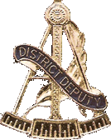Worthy Sirs:
I will start by saying it has been another wonderful month. Each and every Council was actively recruiting in the month of January. Each Council brought in at least one new member.
I would like to welcome and congratulate the 13 new members who joined you Councils and our District during January. I know that each of you will go out of your way to show them the ropes and make them each feel welcome and glad they have joined us. With each new member we get closer to our membership goals.
I would also like to congratulate the 21 members who completed the Formation Degree. Well done to all. We look forward to seeing you all at the next Knighthood Degree.
I would like to thank GK Grillo and Council 14573 for hosting the District Dinner Dance. The food was wonderful and the fellowship between Councils was fantastic. Well done! I look forward to the next on we do as a District.
I would be remiss if I didn’t say something about the Knights of Columbus Insurance. If you are not an Insurance member in the order, I ask that you consider it. Give it some heartfelt thought and prayer, if for no other reason than knowing that those you leave behind will have someone to help them navigate through all the paperwork and red tape that comes when trying to claim benefits.
If you are not an Insurance member, you do not have this very important and much needed benefit. For the sake of your loved ones, if for no other reason, consider becoming an Insurance member.
May God bless you and your families,
Vivat Jesus,
Doug Blair
District Deputy #30

Membership – Once again, we are moving into another busy time of year. We prepare for Lent and Easter season. RCIA, CCD, Forst Communion and all religious education classes are finishing up. This is the perfect time to meet with some of the men participating in these programs and tell them about the Knights of Columbus. If you know of a man who is going to be joining the church during Easter tell him about we do, give him a prospect card, a council brochure or if he is truly interested in joining a Form 100. Don’t forget, if he says he is too busy, offer him the opportunity to join electronically. We have had two electronic members so far and they have both become active members in our council.
What’s happening
Feb. 2 & 3 – Membership Drive after all Masses in Feb. 5 – Business Meeting – Election of Delegates to State Convention Feb. 9 – Valentines Dinner/dance Feb.19– Social Meeting (Habitat for Humanity Presentation) Feb. 20 - F.I.T. Spaghetti Dinner – 4PM on campus- volunteers needed Mar. 2 – Mardi Gras Dinner/Dance
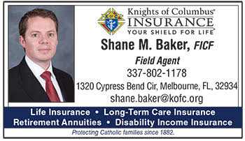
Insurance Agent’s Report
Have You Insured Your Most Valuable Asset?
Is your income protected if you become sick or injured and cannot work? Your ability to work and earn an income is your most valuable asset. Yet a disability could prevent you from earning that income. Just one year of a disability could eliminate your savings.
Income Armor, an individual disability income insurance product from the Knights of Columbus, should be a key part of your overall financial plan and family’s protection.
If you are ill or injured, Income Armor provides tax-free monthly benefits to help you meet living expenses and maintain you and your family’s standard of living. Your monthly benefits help you pay your mortgage and other monthly bills, while your savings and retirement assets remain intact.
In short, if you have a job and don’t have a way to protect that paycheck, you should seriously consider Income Armor today. I look forward to meeting with you.

Sane.Baker@kofc.org Phone: 1-331-802-1178

Archbishop Lori’s Challenge for February 2019
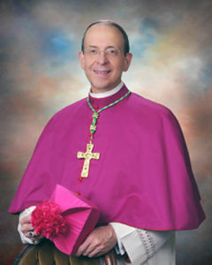
After all the people had been baptized and Jesus also had been baptized and was praying, heaven was opened and the Holy Spirit descended upon him in bodily form like a dove. And a voice came from heaven, “You are my beloved Son; with you I am well pleased.” — Gospel for Jan. 13, Lk. 3:21-22
Think about it. Do you really see yourself as a beloved son in whom your Heavenly Father is well pleased? To be honest, most men, including this archbishop, go through seasons when we don’t seem to sense that our father is well-pleased. Maybe we see ourselves as self-made men who don’t owe our father anything. Maybe we did not experience love from our dad, and the very idea of being beloved is ludicrous. Maybe instead of Jesus’ actual words, we hear, “This is my wayward son, in whom I am much disappointed.” Yet we know that we are baptized into Christ and share in his identity as the beloved son. Being beloved sons is the bedrock of our identity. The plain fact is that your heavenly Father is well-pleased with you.
The Challenge This month: I challenge you to hear the Heavenly Father saying these words — “you are my beloved son” — personally to you, and reflect on your identity in him. I recommend that you do so, if possible, in Adoration. Secondly, I challenge you to spend time with someone who loves you unconditionally. Ask them why? Their answer should give you a small glimpse of God’s unconditional love
. Anniversary of Knighthood
Feb. 1 – David Hebert Feb. 12. – Ezra James 02/ 01/62 – David Sterman 02/16/99 – Ed Schmitt Feb. 3 – Paul Headlee Feb. 18 – Dr. Miguel Cartagena 02/01/75 – Stanley Chelsea 02/16/99 – Adrain Sequeira Feb. 09- Santaigo Garcia Feb. 18 – Michael Otten 02/07/91 – Dea. William Wanca 02/02/04 – Angel Hernandez Feb. 10 – Oscar Lopez 02/25/93 – Jack Davis 02/23/04 – Robert Lepri
The Family Fully Alive BUILDING THE DOMESTIC CHURCH
Meditation:
The foundation of the domestic church is the sacrament of marriage. It is therefore important to reflect often on the mystery and calling of this sacrament. Also, our children may to become spouses and parents, so it is important to help them understand the type of love that is necessary in marriage and family life. Breaking Open the Theme The sacrament of marriage is a wondrous divine mystery. As Archbishop Fulton J. Sheen liked to remind couples, it takes “three” to get married: husband, wife and God. 46 by virtue of the sacrament of baptism, Christians no longer belong to themselves, but to Jesus Christ. as a result, when a baptized man marries a baptized woman, Christ himself is the one who gives the spouses to each other on their wedding day. It is Christ who also receives their vows as the Church witnesses their exchange of love and blesses it in Christ’s name. This is why it is important to celebrate the sacrament of marriage in a church where the Blessed Sacrament is present and also why the Church recommends that Christian marriages take place within a Mass. 47 Christ, who is truly present in the Blessed Sacrament, is made present in the love of the spouses. He becomes the source and unshakable guarantor of their unity as a couple. He transforms their love: “spouses love each other with a love that is greater than themselves, in fact, with the very love that brought them into existence in the first place!”49 by virtue of the great sacrament of holy matrimony, human love participates in Christ’s own sacrificial love wherein he gave up his body for sinners on the cross. To receive the graces of this sacrament fully, married couples must enter into the total self-gift of Christ on a daily basis, holding nothing back in their love of each other through prayer and sacrifice for the good of the beloved. Meditations From a homily by St. John Chrysostom on Marriage and Family Life How is marriage a mystery? The two have become one. This is not an empty symbol. They have not become the image of anything on earth, but of God Himself. ... They come to be made into one body. see the mystery of love! If the two do not become one, they cannot increase; they can increase only by decreasing! How great is the strength of unity!
John Paul II’s familiaris Consortio The spirit which the lord pours forth [in the sacrament of marriage] gives a new heart, and renders man and woman capable of loving one another as Christ has loved us. Conjugal love reaches that fullness to which it is interiorly ordained, which is the proper and specific way in which the spouses participate in and are called to live the very charity of Christ who gave Himself on the Cross. ... spouses are therefore the permanent reminder to the Church of what happened on the Cross; they are for one another and for the children witnesses to the salvation in which the sacrament makes them sharers. 51 1. Do we think of marriage differently when we remember that Christ is present in the sacrament of marriage? How does this change or challenge our personal views of love? 2. What do we think of St. John Chrysostom’s principle of Christian married love — that spouses and family “increase” by “decreasing”? How does this principle relate to the words that we hear from John the Baptist: “He must increase; I must decrease” (Jn 3:30)? 3. Have we loved each family member by sacrificing for them as Christ has done for each of us? In what ways do each of us do this? In what ways could we be better at this? Scripture Reading — Psalm 128 A prayer of the happy home that follows the Lord blessed are all who fear the Lord, and who walk in his ways. What your hands provide you will enjoy; you will be blessed and prosper: Your wife will be like a fruitful vine within your home, Your children like young olive plants around your table. Just so will the man be blessed who fears the Lord.
Project Read Family the below nuptial prayer from the order of Celebrating Matrimony. share memories about your wedding day with your family over a meal. at this meal, have each child share one thing they appreciate about their parents’ marriage. Then, each spouse should share one reason why they are grateful for their marriage and how each one sees Christ as present in their marriage.

.

