April 2019
Our Lady of Grace
Council #13243
Knights of Columbus
Palm Bay, Florida USA

“God’s love is unbounded. It has no limits.”

Grand Knights Message: We began March activities with a membership drive that gained us two new members. Danny Avarado and Anthony Alabruda. Danny completed his 1st degree on Mar. 14 and we brought in 2 others at this degree: Paul Kimmel and Jay Carrasquillo. We are having scheduling issues for Anthony’s 1st degree.
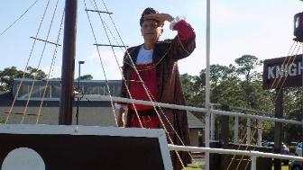 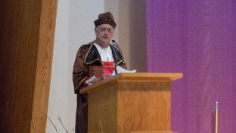 On March 16, council members played a kickball game with residents of Promise in Brevard and Special Olympics athletes at the Space Coast Field of Dreams. We also invited Coast Early Intervention Center. It rained pretty much the entire we played but it didn’t hinder the players. After the kickball game we hosted a pizza party for all the participants. During the pizza party we presented $1000.00 checks to representatives from Space Coast Early Intervention Center, Promise in Brevard, Special Olympics Brevard and Space Coast Field of Dreams. More information and pictures will be available in the April edition of Florida Catholic, and the State Council Newsletter “Innovation”.
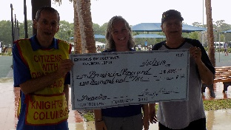 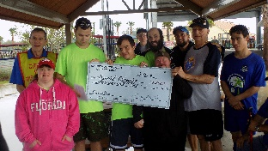 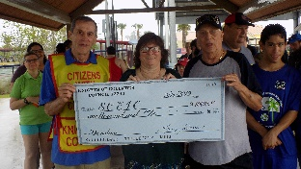 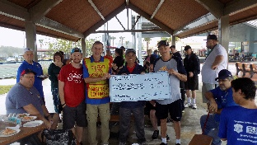 Everyone had a great time even in the rain. 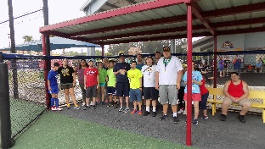 The following day I was invited to Promise and was introduced at the staff meeting and given a round of applause. Then I got to meet the participants from Promise and received hugs from all. The staff extended their gratitude for including the Promisers in the game and challenged us to another game in the near future.
Our next excursion was to Pregnancy Resource Center on Babcock Street. On March 25, Knights of Columbus Day of the Unborn Child several Knights and ladies from the CCW took a prayer tour of the facility and learned all they do for the women of our area. While there we were able to present a check from the proceeds of the District Dinner Dance in Jan for $1539.02. Due to the generosity of an anonymous donor to our council we were able to present another check for $1000.00 from our council to support the good work the center does free gratis.
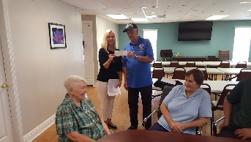 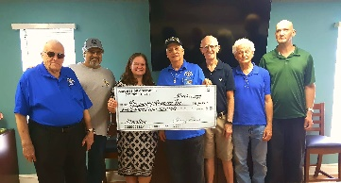 The sad news is that we lost two brother Knights, Life member Leon Kamienski on Mar. 2.and our brother Barry Warshawsky on Feb. 27. As well Barry’s wife Margie who passed 3 weeks after Barry. Knights of Columbus Honor Guards were present at both funeral services. On Saturday, March 30 we held a Lenten Rosary service led by assembly brothers. Adoration of the Blessed Sacrament took place at the same time. A beautiful and serene time with our Lord as we prayed to Our Lady. As of the end of March, we have surpassed our membership goal of 9 new members with a total new membership of 14 this council year. We are still drastically behind in acquiring “INSURED” members. If you do not have K of C insurance you owe it to yourself to at least speak with our insurance agent Shane Baker. If you don’t need or want our insurance, then he can help you with other plans to protect your family, such as K of C Annuities. Shane can be reached at 337-802-1178 or email him at shane.baker@kofc.org or thru kofcgittoagency.com.
Membership – Easter is here, and so are new Catholic members. One pitfall to every Catholic member or convert, is not being involved in the Catholic community. The Knights of Columbus are the answer to this. Every man in RCIA should be brought into the largest lay Catholic organization in the world. Let’s get out and ask these men to join, and provide them and their families with a multifaceted Catholic support system that is desperately needed in the world today.
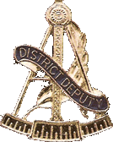 Message from the District Deputy: Happy April, and no this is not an April fool’s Joke. It has been a great month for our Councils and for our District. Nothing good happens in the District without your Councils being hard at work.
I would like to begin by thanking you all for your participation and support of all of this year’s youth activities. Each of your Councils helped me to host the District, Regional and State Soccer Challenge and the Basketball Free Throw Competitions. I would like to thank SK Herm Bishop and SK Pat Farrelly for their unwavering support in both events. I would also like to thank the Ladies of Council 14573 who took time out of their days and took care of both the registration desk and rechecking scoring for both events. I send my personal thanks to all of you.
The end of March closes out the end of the third quarter of this Fraternal Year. Each of you, as Councils, is still within striking distance of the Coveted STAR COUNCIL AWARD.
The Father McGivney Award for membership growth is well within the grasp of each of you as well. Just one good Membership drive and it is yours.
The Founders Award is not out of the question for all of you either. We all know that Insurance in this day and age is a hard sell. Sitting down with one of our Field Agents costs you nothing. When the time comes for your wife and family to get assistance with the piles of paperwork that come with your death, that help is not there if you were not an Insurance member with the Knights. However, with as little as a $300.00 annuity, it is. Is the peace of mind not worth that small price?
Each of your Councils has done many great things this year. It’s time to take stock of your good deeds and start working on your Columbian Award. Some have said that they did not join the Knights of Columbus for the trophies and awards. To that, I say that those trophies and awards are a testament to the hard work and sacrifice you as Council members provide in supporting your Families, your Parish, and your Community each and every day. Each of you are making this world a better place to live in.
As a reminder, our next Knighthood Degree will be held at Fr. Gabriel Hall on April 13th. Candidates need to arrive not later than 9:30 and the Degree will begin at 10:00. A Council Check for $10.00 for per candidate attending made out to Florida State Council is required. Remember that the Candidates do not pay this fee. It is the responsibility of the Council.
The next Patriotic Degree will be conducted in West Palm Beach on the 15th of June. More Information concerning this Degree will follow as the time draws near.
As for the Florida State Raffle you have all been working to sell books of tickets for. Remember that half the price of each ticket stays in your Council. That’s $6.00 per book. It’s free money for your Council. Now, for the good news. I would like to congratulate Phillip Rucki of Council 13243 who hit it big in the Early Bird Drawing and Won $400.00 for his efforts. Well done Phillip!!!
And lastly, it’s that time again. The time to start discerning what position you will fill in your Council. Each of us has a role to play in our Council in the coming year. Will you be an officer, director or will you take on one or two projects to assist and support? The minimum I ask is that each of you be at least a 24 hour Knight. If you don’t know what that is or you’re not sure, seek me out. I would be glad to tell you all about it and it’s much easier than it sounds.
God Bless you all,
Doug Blair
District Deputy #30

Whats happening in April:
Apr. 2 – 7:00 PM – Liturgy of the Word followed by Council Business Meeting Apr. 5 & 6 - 9 AM to 5 PM - Council Tootsie Roll Drive Apr. 7 – 6:30PM – Movie “Unplanned” free for ticket holders at Cinema World Apr. 8 – 7:00 PM – Movie “Unplanned” free for ticket holders at Cinema World Apr. 13 – 9:30 AM – Knighthood (3rd)Degree @ Fr. Gabriel Council Hall Apr. 27 thru May 12 – after all Masss - Baby Bottle Drive to raise funds for Pregnancy Resource Center
Archbishop Lori’s Challenge:
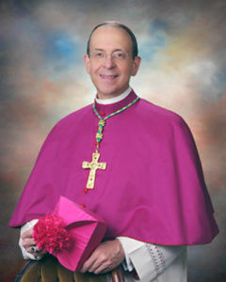 So he got up and went back to his father. While he was still a long way off, his father caught sight of him, and was filled with compassion. He ran to his son, embraced him and kissed him. (Gospel for Mar. 31, Lk 15:20)
. My brother Knights, here we encounter upon some of the most stunningly beautiful words in the entire Gospel: the reunion of the prodigal son with his father. As Jesus describes the scene, I invite you to put yourself in three different sets of shoes. First, imagine that you are the father, seeing your own flesh and blood, your son, coming home. Second, imagine that you are the prodigal son, expecting the worst, but finding that your father is moved with compassion. Third, imagine that you are the hard-working older brother, watching this reunion from a critical distance. Becoming the man we are means that we can learn from all three: embracing others with the mercy of the father; running to our heavenly Father like the Prodigal, and with the older brother, hearing the father’s words spoken to us—that “all that I have is yours’.”
This month I challenge you to be like the Prodigal Father by making the first move: take the first step toward another person in your life to encourage or forgive them. Secondly I challenge you to prayerfully write a list of things in your life for which you are grateful.
This month I challenge you to be like the Prodigal Father by making the first move: take the first step toward another person in your life to encourage or forgive them. Secondly I challenge you to prayerfully write a list of things in your life for which you are grateful
. Anniversary of Knighthood
04/01- Gary Patrovich 04/22- Jim Cleary 04/01/64- Phillip McCutcheon 04/17/13- Quinton Dallas 04/02- Sammy Mangual 04/22- Richard Seeberger 04/13/94- Parker Ward 04/17/13- Juan Linares 04/04- Pedro Fernandez 04/23- John Buchanan 04/11/96- Ezra James 04/13/17- Michael Smith 04/12- William Crewe 04/22/04- Jack Rhine 04/20/15- Ron Gento 04/10/08- Ken Gilbert 04/20/15- Albert Gutierrez 04/28/08- Santiago Garcia 04/06/17- Esperant Edouard 04/27/09- Jim Cleary 04/06/17- Dr. Joven Garcia 04/27/09- Tim Jacques 04/06/17- Ed Trotter 0 04/17/13- Victor Cotto 04/02/18- Jeff Stephen
The Family Fully Alive BUILDING THE DOMESTIC CHURCH
April : Mercy and Forgiveness
Once we allow ill will to take root in our hearts, it leads to deep resentment. The opposite of resentment is forgiveness, which is rooted in a positive attitude that seeks to understand other people’s weaknesses and to excuse them. As Jesus said, “Father, forgive them; for they know not what they do”. Yet we keep looking for more and more faults, imagining greater evils, presuming all kinds of bad intentions, and so resentment grows and deepens…Something is wrong when we see every problem as equaly serious, in this way, we risk being unduly harsh with the failings of others. The just desire to see our rights respected turns into a thirst for vengeance rather than a reasoned defense of our dignity.
When we have been offended or let down, forgiveness is possible and desirable, but no one can say that it is easy. All this assumes that we ourselves have had the experience of being forgiven by God, justified by his grace and not by our own merits. We have known a love that is prior to any of our efforts. A love that constantly opens doors, promotes and encourages.
- What do Scriptures teach us about how to forgive our family members?
- Why is it important to be forgiven by God? Why must we trust in his forgiveness in order to forgive others properly?
- Do any of us find it hard to forgive? What holds us back from forgiving? Is it based on ill will, unduly looking for faults, the inability to forgive ourselves or to accept our own limitations?

.

