December 2018
Our Lady of Grace
Council #13243
Knights of Columbus
Palm Bay, Florida USA

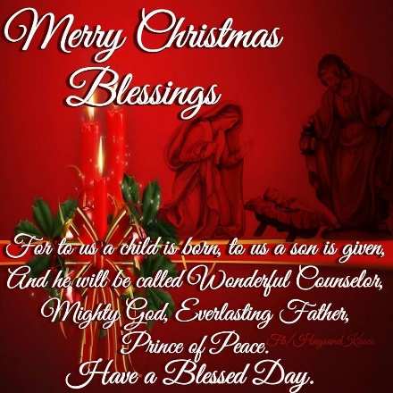 Wishing all brother Knights and their families a Blessed and Merry Christmas.
“The method that speaks strongest of Christ is love. As Knights, we should be prepared to let charity be our measure of the new evangelization. In this way, we can truly promote a ‘charity that evangelizes’.” --Carl Anderson, Supreme Knight

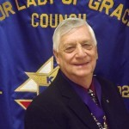
Grand Knights Message
We started November off right by bringing in two new members to our council, Dan Fisher and Douglas Shugart. This brought us to our annual quota of 9 new members. Now we need to concentrate on new insurance members. Remember the Knights also offers a great annuity program. You can begin an annuity for as little as $300.00. And with a Knights annuity your rate will never drop below 4%, guaranteed. Some members of our council attended the Veteran’s Day dinner at St. Joseph’s council hall. This was a joint effort between the two assemblies. Food was good and fellowship great.
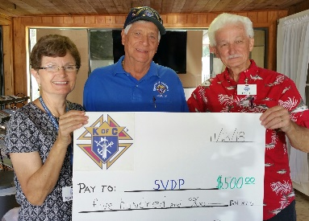On Tuesday, Nov. 13, I was able to attend the monthly meeting of St. Vincent DePaul and present them with a check for $500 as part of the Knight’s Food for Families program. For every $500 or 1000 lbs. Supreme refunds us $100.
We were also able to donate $250.00 to the parish Youth Group to help defray some of the expenses for their recent retreat. This was also our way of saying “Thanks” to the youth for assisting in unloading the pumpkin truck and placing pumpkins on pallets.
On Wednesday, Nov. 28 several Knights ; Ron Gento, Ramon Calderon, Mark Stephenson, Sammy Manguel, Andy Miles, Dennis & Joann Kelleher and Larry Davis cooked and served spaghetti to the students at F.I.T. Always a good time and the students more than appreciative. If you have never participated in this event you should consider it.
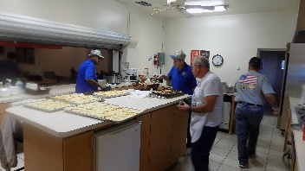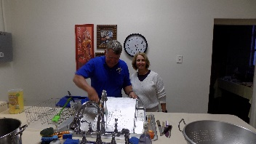
As approved by the council at the November business meeting, I presented Fr. Emmanuel a check for $2500.00. Fr. has earmarked this money for purchase of security cameras around the outside of the church buildings. He is getting quotes at this time.
I want to include our trip to St. Augustine for a visit to the Mission Nombre de Dios and the Nights of Lights. 52 parishioners ( including 5 Knights and their families ) made the trip. Our first stop was Mission Nombre de Dios. Some attended Mass at Prince of Peace church on the grounds. 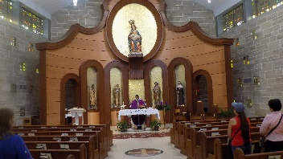 We visited the Shrine of Our Lady of the Milk and Happy Birth.. 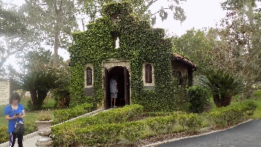 and inside the chapel….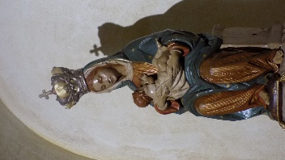 Our tour took us to Old Town St. Augustine where we shopped, walked, and dined along St. George St. 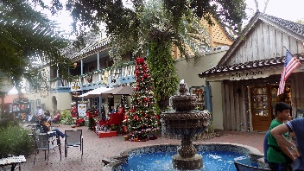 and some visited the Bascilica Cathedral of St. Augustine. 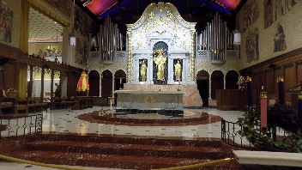 During our tour of the Nights of Lights we were welcomed with a torrential downpour…many of us getting very wet before the bus trip home. Over all it was a wonderful trip and a great way to begin the Advent season.

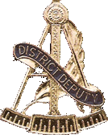
Worthy Brother Knights,
On behalf of my wife Susan and myself, we would like to wish each and every one of our members of the Knights of Columbus a very Merry Christmas and a safe and Joy filled New Year. May we all take the time to remember the true meaning of the Christmas Season. May God’s loving grace fall upon each you and your families and bring peace to all. May our Lords loving hands surround our deployed service members, and keep them and all our first responders safe.
God Bless you all,
Doug Blair
District Deputy #30

Membership - This Christmas give the gift of membership. What is the gift of membership? It’s knowing you are a part of something bigger than yourself. It’s knowing your contributions count for something. When the Supreme Knight talks about the millions of dollars or the millions of service hours, remember this started with one man, working one hour or donating one dollar. We are like drops of rain and when we come together, we change our community and the world. Another gift of membership is being part of a large family of Knights. We eat together, we pray together and for each other. In this time of Advent, think of the gifts you have given to the Knights and the gifts the Knights have given to you. Give the gift of membership.
What’s happening in December:
Dec. 2 - Bus trip to St. Augustine - Mission Nombre de Dios and Nights of Lights Dec. 4 – Council Business Meeting Dec. 6 – Welcome meeting for new parishioners Dec. 8 – Melbourne Christmas Parade - Knights of Columbus councils have the honor of leading the parade. Dec. 18 – Council Christmas party and sing-a-long. Dec. 24 – Decorate the church for Christmas. Dec. 30 – Consecration of the Holy Family after all Masses. Dec. 31 – Parish New Year’s Eve Dinner/Dance party
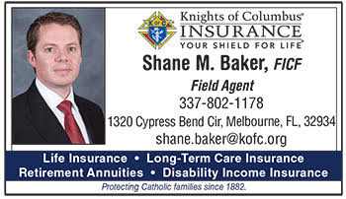
Insurance Agent’s Report
Think You Are Too Old for Coverage? Maybe Not
You are never too young or too old to consider purchasing life insurance. If you have a financial need for coverage, or will in the future, a permanent life insurance policy can be just the thing you need.
When you are young and presumably healthy, coverage will be very inexpensive when compared to purchasing the same policies when you are older.
If you’ve put off purchasing coverage, or you realize that you may need additional insurance, the Order may still be able to help you, even if other companies cannot. In fact, in 2012, the issue age of our permanent life insurance products was extended to age 80, and in 2014, the issue age of our term insurance was extended to age 70. Naturally, your health, and whether or not you smoke, will be taken into consideration, so underwriting standards for risk and age apply. But, the extensions are a great blessing for me – and it could be for you too. Now I can help members that I couldn’t help before. Are you or one of your brother knights one of those members?
Whether you’re 18 or 80, the Knights of Columbus has products that will work for you and your family. I look forward to discussing coverage with you.

Shane.Baker@kofc.org Phone: 1-331-802-1178

Archbishop Lori’s Challenge for December 2018
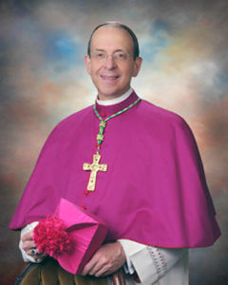
Jesus said to his disciples, “In those days after that tribulation the sun will be darkened…and the powers in the heavens will be shaken. But of that day or hour, no one knows, neither the angels in heaven, nor the Son, but only the Father. (Gospel for Nov. 18, Mk. 13:24, 32)
There’s an old country Gospel song with a catchy refrain that asks this question: “What would you do if Jesus came to spend the day with you?” As Advent quickly approaches, the Church invites us to ponder this question—and prepare our hearts and souls accordingly. We frantically prepare for Christmas, buying gifts and decorating our homes. But will we prepare our soul with the same sense of urgency, purpose, and care? Advent is a sobering time of reflection on the second coming of Jesus. “What would you do if Jesus came to spend the day with you?” Soon he will. May we meet him with open arms and pure hearts.
Challenge by Supreme Chaplain Archbishop William E. Lori:
This month, recalling that we do not know the “day or the hour,” I challenge you to go confession, and make a commitment to go monthly thereafter as a means of maintaining vigilant care over your soul. Secondly I challenge you in the coming month to forgive someone who has hurt you in some way.

Anniversary of Knighthood
12/06 – Phil Rucki 12/20 – Esperante Edouard 01/04 - Frank De La Rosa 14/09 - Dominic Fechas 12/06 -Christopher Tompkins 12/23 – Joseph Little 09/02 – Gary Nolte 14/09 – Manuel Fechas 12/11 – Mark Peoples 12/25 – Kevin Hourihan 09/02 – Thomas Gosselin 02/13 – Alex Boullion 12/13 – Thomas Gosselin 12/25 – Noel Underwood 09/02 – Emilio Burke 07/15 – Miguel Aguilu 12/15 – Leon Kamienski 12/26 – Greg Pelzer 09/02 – William Cox 16/17 – Cameron Mears 12/19 – Leo Nelson 12/29 – Mark Stephenson 09/02 – Dea. Kevin Crawford 16/17 – Quentin Mears 12/28 – Isaiah Cochrane 12/30 – Ray Quinn 18/02 – Adrian Rines 16/17 – John (JT) Kenney 23/03 – John Buchanan 16/17 – Hector Cumba 14/09 – Ted Del Rosario
Family Fully Alive….December
Like the Church herself, the domestic church is called to be a like the Church herself, the domestic church is called to be a CommunIon of SaInts by virtue of baptism and the sacramental graces of marriage, the Christian family is built into a communion of saints. Holiness is a gift given to every baptized Christian that becomes a joyful task for the whole of life. Breaking Open the Theme like the Church herself, the domestic church is called to be a communion of saints. Our response to the call to holiness is important if we are to become the family God wants us to be. We may think of saints as people who lived long ago or are far removed from our everyday experiences. but the saints are close at hand, and God wants to make each of us a saint. each member of the family has the task of helping the others to grow in holiness through faith, hope and love. There are many examples of canonized saints and beatified blessed who can inspire families today. one example of a modern-day saint is blessed Chiara Luce Badano, who was born in 1971.at the age of 17, she was diagnosed with a serious and painful illness. faced with this cross, Chiara prayed and found the courage to accept this as part of God’s loving plan for her. During the whole time of her illness, she turned everything into an opportunity to love. as she lay dying at the age of 18, she said to her mother, “oh Mamma. ... You see I can’t run anymore, but how I would like to pass on to them [young people]the torch [of faith], like in the Olympics! Young people have only one life and it’s worth spend it well.”87 becoming a saint is like running a race. 88 The family is the training ground for this race, where the virtues are taught and character is formed. Through the family, God provides what we need to run it well. To become a saint is simply to cooperate with God and allow him to mold us into the person that he had in mind when he created us. It is his plan to bring us fully to life.
Meditation From Pope Benedict XVI’s General Audience, April 13, 2011 Holiness, the fullness of Christian life, does not consist in carrying out extraordinary enterprises but in being united with Christ, in living his mysteries, in making our own his example, his thoughts, his behavior. The measure of holiness stems from the stature that Christ achieves in us, in as much as with the power of the Holy spirit, we model our whole life on his. … What is of holiness? … What is the essential means never leaving a Sunday without an encounter with the Risen Christ in the Eucharist; this is not an additional burden but is light for the whole week. It means never beginning and never ending a day without at least a brief contact with God. and, on the path of our life it means following the “signposts” that God has communicated to us in the Ten Commandments, interpreted with Christ, which are merely of what love is in specific situations. … We might ask ourselves: can we, with our limitations, with our weaknesses, aim so high? During the liturgical Year, the Church invites us to commemorate a host of saints, the ones, that is, who lived charity to the full, who knew how to love and follow Christ in their daily lives. They tell us that it is possible for everyone to take this road. … I would like to ask all to open themselves to the action of the Holy spirit, who transforms our life, to be, we too, as small pieces in the great mosaic of holiness that God continues to create in history, so that the face of Christ may shine out in the fullness of its splendor. let us not be afraid to aim high, for God’s heights. 89 1. What is holiness? 2. How can we live holiness in the family? How do we love God in the ordinary circumstances of life? 3. How do the saints help us live out holiness? Meditation From Pope Benedict XVI’s General Audience, April 13, 2011 Holiness, of Christian life, does not consist in carrying out extraordinary enterprises but in being united with Christ, in living his mysteries, in making our own his example, his thoughts, his behavior. The measure of holiness stems from Christ achieves in us, in as much as with the power of the Holy spirit, we model our whole life on his. … What is the soul of holiness? … What is the essential? The essential means never leaving a Sunday without an encounter with the Risen Christ in the Eucharist; this is not an additional burden but is light for the whole week. It means never beginning and never ending a day without at least a brief contact with God. and, on the path of our life it means following the “signposts” that God has communicated to us in the Ten Commandments, interpreted with Christ, which are merely the explanation of what loveis in specific situations. … We might ask ourselves: can we, with our limitations, with our weaknesses, aim so high? During the liturgical Year, the Church invites us to commemorate a host of saints, the ones, that is, who lived charity to the full, who knew how to love and follow Christ in their daily lives. They tell us that it is possible for everyone to take this road. … I would like to ask all to open themselves to the action of the Holy spirit, who transforms our life, to be, we too, as small pieces in the great mosaic of holiness that God continues to create in history, so that the face of Christ may shine out in the fullness of its splendor. let us not be afraid to aim high, for God’s heights.
1. What is holiness? 2. How can we live holiness in the family? How do we love God in the ordinary circumstances of life? 3. How do the saints help us live out holiness?

.

