November 2018
Our Lady of Grace
Council #13243
Knights of Columbus
Palm Bay, Florida USA

“The family as domestic church is central to both the work of the new evangelization and to the future sustainability of our parishes – also the future sustainability of the order.”
- Carl Anderson, Supreme Knight
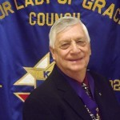
Grand Knights Message
First I would like to thank all the brothers who volunteered their time and talents at the Pumpkin Patch. We received 2,657 pumpkins. I also want to recognize Maria Sierra and the members of Our Lady of Grace Youth Group for all their help in unloading the pumpkin truck and placing the pumpkins on the pallets. The Hayride was a big success as always. Mark Stephenson, Ramon Calderon, Jim Cleary, David Harris and myself took turns driving the tractor. The pumpkin patch also provided a location for 10 elementary VPK classes and Day Care Centers to visit on their field trips. The young children were so excited to see the pumpkins and take a hayride. We sold $15037.75 worth of pumpkins. Out of this the council gets to keep 33 1/3 % or 5007.57. I would also like to thank the Brother Knights who closed out the pumpkin sales and helped take down the tents, load the pallets and return them. Special thanks to Mark and David for their hard work.
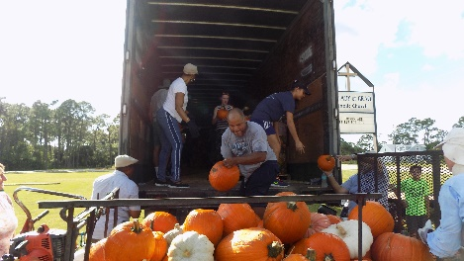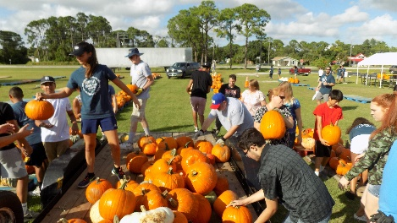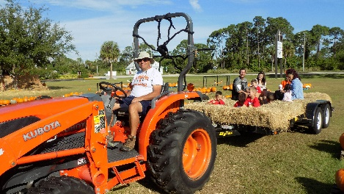
Other events during October were the Tootsie Roll Drive, the Patriotic Rosary and Life Chain. Thanks to all the brother Knights for taking time to volunteer at these events. The Support our Seminarian dinner dance had to be cancelled as only two tickets were sold. As voted on at the last meeting, we purchased 40 bibles to be used as sacramental gifts for those completing the RICA program and parishioners in need of a bible. We have received those bibles and given them to the church.
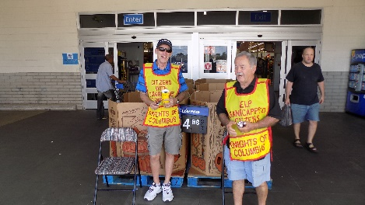

A brief look at upcoming in November:
Saturday, Nov. 10 - Veteran’s Day Dinner at St. Joseph’s Hall – Free for Veterans, all others donations
Sunday, Nov. 11 - Presentation of Family of the Month for October after 6 PM Mass - Presentation of Certificate of Appreciation to OLOG Youth Group for their assistance with Pumpkin Patch, and a check to provide scholarships for their upcoming retreat. Tuesday, Nov. 13 – Presentation of check to SVDP/Loaves & Fishes Wednesday, Nov. 14 – District Deputy Meeting at Fr. Gabriel Council Hall Tuesday, Nov. 20 - Last day to reserve and pay for trip to St. Augustine. Wednesday, Nov. 28 - Cook & Serve Spaghetti dinner for F.I.T. students

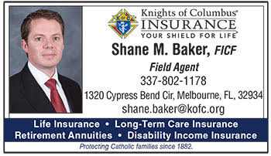
Insurance Agent’s Report
The Value of Life Insurance for Children
As a father, you worry about your children and do everything you can to protect them. You try to raise them right and make sure they are prepared to become adults. But have you ever thought about buying life insurance for your child?
When you insure a child, you are protecting his or her future. Did you know that one out of every six adults get rated, postponed, or denied for insurance coverage? If you purchase a policy for your child from the Knights of Columbus with a guaranteed purchase option, it guarantees that more insurance can be purchased for that child at certain set dates, without proving insurability.
Unfortunately, as fathers we don’t have a crystal ball, and we don’t know what the future may have in store for our children’s health. But did you know that right now you can purchase a child’s policy, in many cases, for less than $10 a month?
I’ve heard it said that people don’t want to “profit” from the death of a child, so they
Contact me today to discuss the many policy options for child plans, including 10- and 20-Pay life insurance won’t purchase coverage on their children. God forbid something tragic happens, those funds can come in handy at a time when finances will be the last thing on a parent’s mind. I have never heard a story about someone who regretted buying coverage on their child..
Call or email Shane to make an appointment. We have a goal of 4 insured members this council year. HOw
Shane.Baker@kofc.org Phone: 1-331-802-1178

Archbishop Lori’s Challenge for November 2018
November 2018
Jesus said to his disciples, “In those days after that tribulation the sun will be darkened…and the powers in the heavens will be shaken. But of that day or hour, no one knows, neither the angels in heaven, nor the Son, but only the Father. (Gospel for Nov. 18, Mk. 13:24, 32)
There’s an old country Gospel song with a catchy refrain that asks this question: “What would you do if Jesus came to spend the day with you?” As Advent quickly approaches, the Church invites us to ponder this question—and prepare our hearts and souls accordingly. We frantically prepare for Christmas, buying gifts and decorating our homes. But will we prepare our soul with the same sense of urgency, purpose, and care? Advent is a sobering time of reflection on the second coming of Jesus. “What would you do if Jesus came to spend the day with you?” Soon he will. May we meet him with open arms and pure hearts.
Challenge by Supreme Chaplain Archbishop William E. Lori:
This month, recalling that we do not know the “day or the hour,” I challenge you to go confession, and make a commitment to go monthly thereafter as a means of maintaining vigilant care over your soul. Secondly I challenge you in the coming month to forgive someone who has hurt you in some way.

Anniversary of Knighthood
11/21 – Alex Boullion 11/26 – Stanley Chelsea 11/01/74 – Leon Kamienski 11/17/14 - Norman Carrasquillo 11/09 – Victor Cotto 11/01 – James Ford 11/01/83 – Frank Lubbering 11/17/14 – Leo Nelson 11/20 – Dr. Jose Garcia 11/14 – Robert Lepri 11/01/91 – Tim Lubbering 11/15/15 – James Sorrell 11/08 – Osborne McCarter 11/09 – William Raffinello 11/15/04 Marcel Chukwunenye 11/21/16 – Kevin Hourihan 11/24 – Denis Richard 11/03 – James Sorrell 11/15/04 – Gregory Pierre 11/21/16 – Art Tostaine 11/16 – Jerry Staggenborg 11/23 – Misael Velasquez 11/01/05 – Chris Sansonia 11/12 – Barry Warshawsky

Family Fully Alive….November
Like the Church herself, the domestic church is called to be a like the Church herself, the domestic church is called to be a CommunIon of SaInts by virtue of baptism and the sacramental graces of marriage, the Christian family is built into a communion of saints. Holiness is a gift given to every baptized Christian that becomes a joyful task for the whole of life. Breaking Open the Theme like the Church herself, the domestic church is called to be a communion of saints. Our response to the call to holiness is important if we are to become the family God wants us to be. We may think of saints as people who lived long ago or are far removed from our everyday experiences. but the saints are close at hand, and God wants to make each of us a saint. each member of the family has the task of helping the others to grow in holiness through faith, hope and love. There are many examples of canonized saints and beatified blessed who can inspire families today. one example of a modern-day saint is blessed Chiara Luce Badano, who was born in 1971.at the age of 17, she was diagnosed with a serious and painful illness. faced with this cross, Chiara prayed and found the courage to accept this as part of God’s loving plan for her. During the whole time of her illness, she turned everything into an opportunity to love. as she lay dying at the age of 18, she said to her mother, “oh Mamma. ... You see I can’t run anymore, but how I would like to pass on to them [young people]the torch [of faith], like in the Olympics! Young people have only one life and it’s worth spend it well.”87 becoming a saint is like running a race. 88 The family is the training ground for this race, where the virtues are taught and character is formed. Through the family, God provides what we need to run it well. To become a saint is simply to cooperate with God and allow him to mold us into the person that he had in mind when he created us. It is his plan to bring us fully to life.
Meditation From Pope Benedict XVI’s General Audience, April 13, 2011 Holiness, the fullness of Christian life, does not consist in carrying out extraordinary enterprises but in being united with Christ, in living his mysteries, in making our own his example, his thoughts, his behavior. The measure of holiness stems from the stature that Christ achieves in us, in as much as with the power of the Holy spirit, we model our whole life on his. … What is of holiness? … What is the essential means never leaving a Sunday without an encounter with the Risen Christ in the Eucharist; this is not an additional burden but is light for the whole week. It means never beginning and never ending a day without at least a brief contact with God. and, on the path of our life it means following the “signposts” that God has communicated to us in the Ten Commandments, interpreted with Christ, which are merely of what love is in specific situations. … We might ask ourselves: can we, with our limitations, with our weaknesses, aim so high? During the liturgical Year, the Church invites us to commemorate a host of saints, the ones, that is, who lived charity to the full, who knew how to love and follow Christ in their daily lives. They tell us that it is possible for everyone to take this road. … I would like to ask all to open themselves to the action of the Holy spirit, who transforms our life, to be, we too, as small pieces in the great mosaic of holiness that God continues to create in history, so that the face of Christ may shine out in the fullness of its splendor. let us not be afraid to aim high, for God’s heights. 89 1. What is holiness? 2. How can we live holiness in the family? How do we love God in the ordinary circumstances of life? 3. How do the saints help us live out holiness? Meditation From Pope Benedict XVI’s General Audience, April 13, 2011 Holiness, of Christian life, does not consist in carrying out extraordinary enterprises but in being united with Christ, in living his mysteries, in making our own his example, his thoughts, his behavior. The measure of holiness stems from Christ achieves in us, in as much as with the power of the Holy spirit, we model our whole life on his. … What is the soul of holiness? … What is the essential? The essential means never leaving a Sunday without an encounter with the Risen Christ in the Eucharist; this is not an additional burden but is light for the whole week. It means never beginning and never ending a day without at least a brief contact with God. and, on the path of our life it means following the “signposts” that God has communicated to us in the Ten Commandments, interpreted with Christ, which are merely the explanation of what loveis in specific situations. … We might ask ourselves: can we, with our limitations, with our weaknesses, aim so high? During the liturgical Year, the Church invites us to commemorate a host of saints, the ones, that is, who lived charity to the full, who knew how to love and follow Christ in their daily lives. They tell us that it is possible for everyone to take this road. … I would like to ask all to open themselves to the action of the Holy spirit, who transforms our life, to be, we too, as small pieces in the great mosaic of holiness that God continues to create in history, so that the face of Christ may shine out in the fullness of its splendor. let us not be afraid to aim high, for God’s heights. 89
1. What is holiness? 2. How can we live holiness in the family? How do we love God in the ordinary circumstances of life? 3. How do the saints help us live out holiness?

.

